**UTSA AND AAU UNIVERSITIES REPORT DOCUMENTATION**

**I – Data Source**

<https://mup.asu.edu/University-Data>

**II – Get The Dataset**

- Download these datasets:

+ Total Research in Current Dollars

+ Federal Research in Current Dollars

+ Endowment Assets in Current Dollars

+ Annual Giving in Current Dollars

+ National Academy Membership

+ Faculty Awards

+ Doctorates Awarded

+ Postdoctoral Appointees

- Move the datasets to Versus AAU directory (That’s where ‘UTSA VS AAU.ipynb’ is)

**III – Quick Guide to Customize Dataset**

- Move the dataset into the same folder with ‘UTSA VS AAU.ipynb’ - From Windows symbol, select **Anaconda3 (64-bit) -> Jupyter Notebook** (if you did not have Anaconda installed, here’s the link: <https://www.anaconda.com/download/> (Select the version for Python 3)

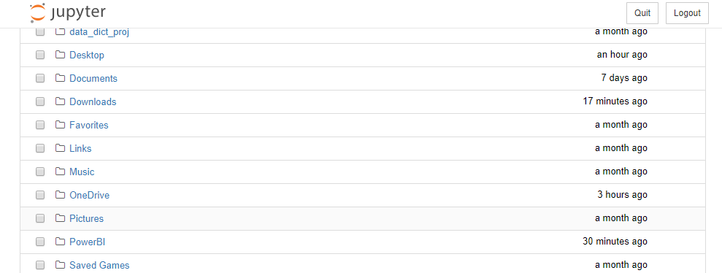- A picture like this should pop up as an Internet Explorer or Google Chrome window

- If the window does not appear, click on the Jupyter Notebook symbol from Windows tool bar and **select** the similar hyperlink like below, and **open it from a web browser**.



- Navigate to where ‘UTSA VS AAU.ipynb’ is. If you’re having trouble finding this file from Jupyter Notebook, it should be similar to how you get to it from regular Windows Navigator.

- Open ‘UTSA VS AAU.ipynb’. A window like this should appear:

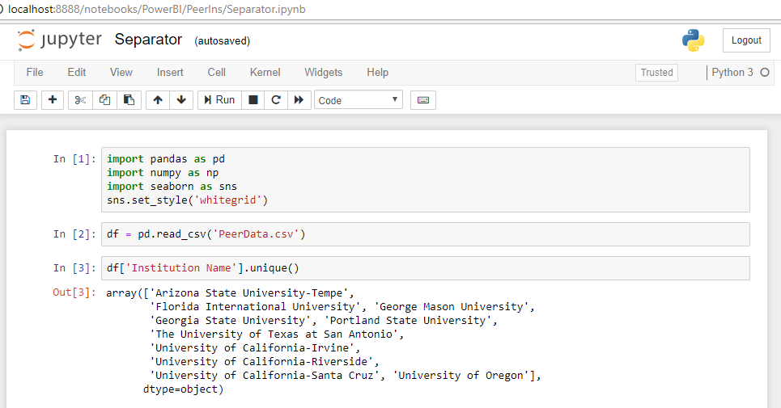

- Select **Kernel -> Restart & Run All**

- For cell by cell documentation, Read Jupyter Notebook UTSA VS AAU.ipynb

- Exported excel files will be formatted as “20XX-20XX.xlsx”